Project Title
LOGISTICS AND OPTIMISATION SYSTEM
Project Report submitted for the partial fulfilment of grade for the course

Data Structures and Algorithms -3 (25CS2103E)
in

A.Y. 2026-2027

Submitted by
Meghana-2520030461
Koushika-2520030459
Bhavya-2520030005
Team Number: 23
Section: 5

Under the guidance of
Yamini devi

<<CSE >>
Hyderabad-500090, Telangana, India.

K L (Deemed to be) University
DEPARTMENT OF COMPUTER SCIENCE ENGINEERING / COMPUTER SCIENCE AND INFORMATION TECHNOLOGY/ARTIFICIAL INTELLIGENCE & DATA SCIENCE



DECLARATION

The Mini Project Report entitled “Project Title” is a record of Bonafide work of meghana-2520030461, koushika-2520030459 , bhavya-2520030005 submitted in partial fulfillment for the award of B. Tech in Computer Science and Engineering/Computer Science and Information Technology/ Artifical Intelligence & data Science to the K L University. The results embodied in this report have not been copied from any other departments/University/Institute.

Meghana-2520030461
koushika 2520030459
bhavya-2520030005
.

K L (Deemed to be) University
DEPARTMENT OF COMPUTER SCIENCE ENGINEERING / COMPUTER SCIENCE AND INFORMATION TECHNOLOGY
CERTIFICATE

This is to certify that the mini project based report entitled “Project Title” is a bonafide work done and submitted by meghana-2520030461, koushika-2520030459, bhavya-2520030005 in partial fulfillment of the requirements for the award of the degree of BACHELOR OF TECHNOLOGY in Department of Computer Science Engineering/ Computer Science and Information Technology/Artificial Intelligence & Data Science, K L (Deemed to be University), during the academic year 2026-2027.

Signature of the Supervisor

Signature of the HOD Signature of the External Examiner

ACKNOWLEDGEMENT

The success in this project would not have been possible but for the timely help and guidance rendered by many people. Our wish to express my sincere thanks to all those who has assisted us in one way or the other for the completion of my project.

Our greatest appreciation to my guide, <<Yamini devi>>, <<Assistant professor>>, <CSE>> which cannot be expressed in words for his/her tremendous support, encouragement and guidance for this project.

We express our gratitude to Dr. P.Venkateshwar Rao (CSE)/Dr. Khaja Shareef (CSIT)/ Dr. Sreenath Itikela (AI&DS), Head of the Department for Computer Science Engineering/ Department for Computer Science and Information Technology/Department of Artificial Intelligence and Data Science for providing us with adequate facilities, ways and means by which we are able to complete this project-based Lab.

We thank all the members of teaching and non-teaching staff members, and also who have assisted me directly or indirectly for successful completion of this project. Finally, I sincerely thank my parents, friends and classmates for their kind help and cooperation during my work.

Meghana-2520030451
Koushika-2520030459
Bhavya-2520030005

TABLE OF CONTENTS

S.No. | Contents | Page no.
1. | Abstract
2. | Introduction
3. | Literature survey
4. | Problem Statement and Objectives
5. | Hardware and Software requirements
6. | Implementation
7. | Results & Discussion
8. | Conclusion & Future Scope
9. | References

1.ABSTRACT

The abstract of a project is a concise summary of the project's main purpose, methods, key findings, and significance. It provides a quick overview of what the project is about, helping readers understand the core aspects without diving into the full details. (150-250 words).
The Logistics Optimization System is a web-based decision-support system designed to optimize the transportation and distribution of goods across a network of warehouses and delivery destinations. The system models warehouses, routes, inventory capacities, transportation costs, distances, and travel times as a weighted directed graph and applies advanced Data Structures and Algorithms to determine efficient logistics decisions.
The core optimization engine uses the Min-Cost Max-Flow (MCMF) algorithm with the Successive Shortest Path approach to maximize the quantity of goods delivered while minimizing the overall transportation cost under inventory and route-capacity constraints. The system represents the logistics network as a residual flow graph and repeatedly identifies minimum-cost augmenting paths to distribute available goods efficiently. It also identifies capacity bottlenecks and reports partially fulfilled demand when the available network capacity is insufficient.
For route planning and disruption analysis, the system incorporates Dijkstra's shortest-path algorithm to identify the cheapest route and a k-shortest-path-inspired alternative route analysis to determine a second-best route. This enables the system to compare routes based on cost, distance, travel time, and capacity and to recalculate optimal decisions when a route becomes unavailable.
The project demonstrates practical applications of advanced DSA concepts including graph algorithms, shortest-path algorithms, network flow, residual graphs, optimization, bottleneck analysis, and algorithmic complexity. Through an interactive web interface, users can manage warehouses, inventory, routes, products, orders, and stock transfers while observing the results of the underlying algorithms. The system therefore provides a practical demonstration of how advanced algorithms can be applied to solve real-world logistics optimization problems involving constrained resources, competing routes, and cost minimization.

Team Name:
optimizers

Team Logo (if any):

Team Members:
- Meghana-2520030461
- Koushika-2520030459
- Bhavya-2520030005

- INTRODUCTION

The introduction of a project sets the stage by explaining the context, background, and motivation behind the project. It answers the what, why, and how questions, helping readers understand why the project is important and what it aims to accomplish.
The introduction is meant to engage the reader, providing enough context to appreciate the project's purpose and importance while also leading smoothly into the project details. It usually ends with a brief outline of what the rest of the document will cover.
The Logistics Optimization System is a software-based solution designed to improve the efficiency of transportation, distribution, and resource allocation in logistics networks. In real-world logistics, organizations need to transport goods between warehouses and destinations while considering factors such as route capacity, transportation cost, distance, inventory availability, and customer demand. Managing these factors manually can result in increased transportation costs, inefficient resource utilization, and delays. This project addresses these challenges by applying advanced Data Structures and Algorithms to model and optimize logistics operations.
The system represents the logistics network as a weighted graph, where warehouses and locations are represented as vertices and transportation routes are represented as edges with associated costs and capacities. Advanced graph algorithms are used to identify efficient routes and optimize the movement of goods. Shortest-path algorithms are used for route analysis, while network-flow techniques, particularly Maximum Flow and Minimum-Cost Flow, are applied to determine how goods can be distributed while satisfying capacity and demand constraints and minimizing transportation costs. The system also provides alternative route analysis to support decision-making when the preferred route is unavailable or constrained.
The primary objective of the project is to demonstrate how advanced DSA concepts can be applied to solve a practical optimization problem. The system provides an interactive platform through which logistics operations can be managed and algorithmic results can be observed. By combining graph representation, shortest-path algorithms, residual networks, network flow, optimization, and complexity analysis, the project demonstrates the practical importance of advanced algorithms in designing efficient and cost-effective logistics solutions. The remainder of this report presents the system requirements, design, algorithms used, implementation, results, and evaluation of the proposed system.

- LITERATURE SURVEY
Dear students, in Literature Survey section of the Hackathon Project Documentation you need to specify the previous similar kind of projects already done with an explanation in a 4-to-5-line paragraph and in References section of documentation you need to specify the URLs of the similar kind of websites which you referred and included in the Literature. Minimum of 5 to 10 similar kind of project you need to refer and do the literature and put the URL links in References.
Several existing logistics optimization systems use graph algorithms and optimization techniques to improve transportation and distribution efficiency. These systems commonly represent locations as nodes and transportation routes as edges with associated costs, distances, and capacities.
Vehicle Routing Problem (VRP) approaches are widely used to determine efficient routes for transporting goods. Capacitated VRP extends this by considering the limited capacity of vehicles, making it useful for real-world delivery planning.
Minimum-Cost Flow algorithms are used to transport goods through a network while satisfying supply, demand, and capacity constraints at minimum transportation cost. This concept is closely related to the proposed Logistics Optimization System.
Shortest-path algorithms, such as Dijkstra's algorithm, are commonly applied to identify efficient routes between locations. Such algorithms help reduce travel distance and transportation costs while providing alternative routes when required.
Existing optimization frameworks such as Google OR-Tools demonstrate the practical use of vehicle routing, network flow, scheduling, and other optimization techniques in logistics applications.
The proposed Logistics Optimization System combines these concepts into an interactive system that demonstrates shortest-path algorithms, network flow, capacity constraints, and cost optimization. Unlike general-purpose optimization frameworks, the project focuses on implementing and demonstrating the underlying advanced DSA concepts for a practical logistics problem.

- Problem Statement and Objectives

Problem Statement: A clear and specific articulation of the problem, outlining its importance.
To develop a logistics optimization system that determines efficient and cost-effective transportation of goods through a network of warehouses and routes using advanced DSA techniques.
Problem Description: A concise explanation of the issue or challenge that needs to be solved.
Logistics operations involve multiple warehouses, routes, capacities, inventory levels, and delivery requirements. Finding suitable routes while minimizing transportation cost and satisfying capacity constraints is a complex optimization problem.
Objectives:
Identify the Project's Purpose:
Determine why the project was initiated and what business problem it aims to solve. Then frame the objectives of your project.

• Optimize Transportation Cost:
Minimize the overall cost of transporting goods between warehouses and destinations.
• Find Efficient Routes:
Use shortest-path algorithms to identify cost-effective routes between locations.
• Optimize Goods Distribution:
Apply network-flow algorithms to distribute goods while considering supply, demand, and route capacities.
• Handle Capacity Constraints:
Ensure that transportation routes are not assigned more goods than their available capacity.
• Identify Alternative Routes:
Provide alternative routes when the preferred route is unavailable or constrained.
• Demonstrate Advanced DSA Concepts:
Apply graph algorithms, shortest paths, residual graphs, network flow, and optimization techniques to a real-world logistics problem.

- HARDWARE AND SOFTWARE REQUIREMENTS
Hardware Requirements:
• Processor: Intel Core i3 or equivalent and above
• RAM: Minimum 4 GB
• Storage: Minimum 10 GB of available space
• Standard keyboard, mouse, and monitor
• Internet connection for development and deployment
Software Requirements:
• Operating System: Windows 10/11 or Linux
• Programming Language: Java
• Frontend: HTML, CSS, JavaScript
• Backend: Node.js / appropriate server environment
• Database: MySQL
• Development Environment: Visual Studio Code
• Web Browser: Google Chrome / Microsoft Edge

- IMPLEMENTATION

Give here 3 to 4 modules code of your project

6.1 Flow Network and Residual Graph
The logistics network is represented as a flow network in which warehouses and destinations are modeled as vertices and transportation routes are represented as directed edges. Each edge contains capacity and transportation cost. For the Min-Cost Max-Flow algorithm, a reverse residual edge with negative cost is also created.
Code:
public FlowEdge addEdge(int from, int to, int capacity, double cost,
Long routeId, String fromName, String toName,
double distanceKm, double travelTimeHours) {

FlowEdge forward = new FlowEdge(
from, to, capacity, cost,
routeId, fromName, toName,
distanceKm, travelTimeHours
);

FlowEdge backward = new FlowEdge(
to, from, 0, -cost,
routeId, toName, fromName,
distanceKm, travelTimeHours
);

forward.setResidual(backward);
backward.setResidual(forward);

adj.get(from).add(forward);
adj.get(to).add(backward);

originalEdges.add(forward);

return forward;
}

6.2 Minimum-Cost Maximum-Flow using SSP and SPFA
The core optimization algorithm is Minimum-Cost Maximum-Flow (MCMF) using the Successive Shortest Path (SSP) approach. SPFA is used to find the minimum-cost augmenting path in the residual network. The algorithm repeatedly sends flow through the cheapest available path until the required demand is fulfilled or no feasible path remains.
Code:
public static McmfResult solve(FlowNetwork network,
int source,
int sink,
int targetDemand) {

int n = network.getNumVertices();
int totalFlow = 0;
double totalCost = 0.0;

double[] dist = new double[n];
FlowEdge[] parentEdge = new FlowEdge[n];
boolean[] inQueue = new boolean[n];

while (totalFlow < targetDemand) {

Arrays.fill(dist, Double.POSITIVE_INFINITY);
Arrays.fill(parentEdge, null);
Arrays.fill(inQueue, false);

Queue<Integer> queue = new ArrayDeque<>();

dist[source] = 0;
queue.add(source);
inQueue[source] = true;

while (!queue.isEmpty()) {

int u = queue.poll();
inQueue[u] = false;

for (FlowEdge edge : network.getAdj(u)) {

if (edge.getResidualCapacity() > 0) {

double newDist =
dist[u] + edge.getCost();

if (newDist <
dist[edge.getTo()] - 1e-9) {

dist[edge.getTo()] = newDist;
parentEdge[edge.getTo()] = edge;

if (!inQueue[edge.getTo()]) {
queue.add(edge.getTo());
inQueue[edge.getTo()] = true;
}
}
}
}
}

if (dist[sink] == Double.POSITIVE_INFINITY)
break;

int pushFlow = targetDemand - totalFlow;

int curr = sink;

while (curr != source) {
FlowEdge edge = parentEdge[curr];

pushFlow = Math.min(
pushFlow,
edge.getResidualCapacity()
);

curr = edge.getFrom();
}

curr = sink;

while (curr != source) {
FlowEdge edge = parentEdge[curr];
edge.addFlow(pushFlow);
curr = edge.getFrom();
}

totalFlow += pushFlow;
totalCost += pushFlow * dist[sink];
}

return new McmfResult(
totalFlow,
Math.round(totalCost * 100.0) / 100.0,
targetDemand,
targetDemand - totalFlow,
new ArrayList<>(),
new ArrayList<>()
);
}

6.3 Shortest Route using Dijkstra's Algorithm
The system also compares routes using Dijkstra's shortest-path algorithm. Each active transportation route is represented as a weighted graph edge, where the route cost acts as the edge weight. A priority queue is used to repeatedly select the node with the smallest current distance.
Code:
PriorityQueue<NodeDist> pq =
new PriorityQueue<>(
Comparator.comparingDouble(nd -> nd.dist)
);

dist.put(start, 0.0);
pq.add(new NodeDist(start, 0.0));

while (!pq.isEmpty()) {

NodeDist current = pq.poll();

if (current.dist >
dist.getOrDefault(
current.node,
Double.POSITIVE_INFINITY)) {
continue;
}

if (current.node.equals(end))
break;

List<GraphEdge> neighbors =
adj.getOrDefault(
current.node,
Collections.emptyList()
);

for (GraphEdge edge : neighbors) {

double newDist =
current.dist + edge.cost;

if (newDist <
dist.getOrDefault(
edge.to,
Double.POSITIVE_INFINITY)) {

dist.put(edge.to, newDist);
prevEdge.put(edge.to, edge);
prevNode.put(edge.to, current.node);

pq.add(
new NodeDist(edge.to, newDist)
);
}
}
}

6.4 Logistics Optimization Service
The OptimizationService connects the application data with the DSA algorithms. It collects warehouses, inventory, orders, and active routes, constructs the flow network, adds the required capacities, and sends the network to the MCMF solver.
Code:
// Add active transportation routes
for (Route route : activeRoutes) {

Integer u = nodeMap.get(route.getSourceName());
Integer v = nodeMap.get(route.getDestinationName());

if (u != null && v != null) {

network.addEdge(
u,
v,
route.getCapacity(),
route.getUnitCost(),
route.getId(),
route.getSourceName(),
route.getDestinationName(),
route.getDistanceKm(),
route.getTravelTimeHours()
);
}
}

// Add destination to Super Sink
Integer destNodeId = nodeMap.get(destinationNode);

if (destNodeId != null) {

network.addEdge(
destNodeId,
superSink,
requestedQty,
0.0,
null,
destinationNode,
"Super Sink",
0,
0
);
}

// Run MCMF
McmfSolver.McmfResult result =
McmfSolver.solve(
network,
superSource,
superSink,
requestedQty
);

- RESULTS & DISCUSSION
Output application run screen shots with their explanation in 2 lines.
login page:
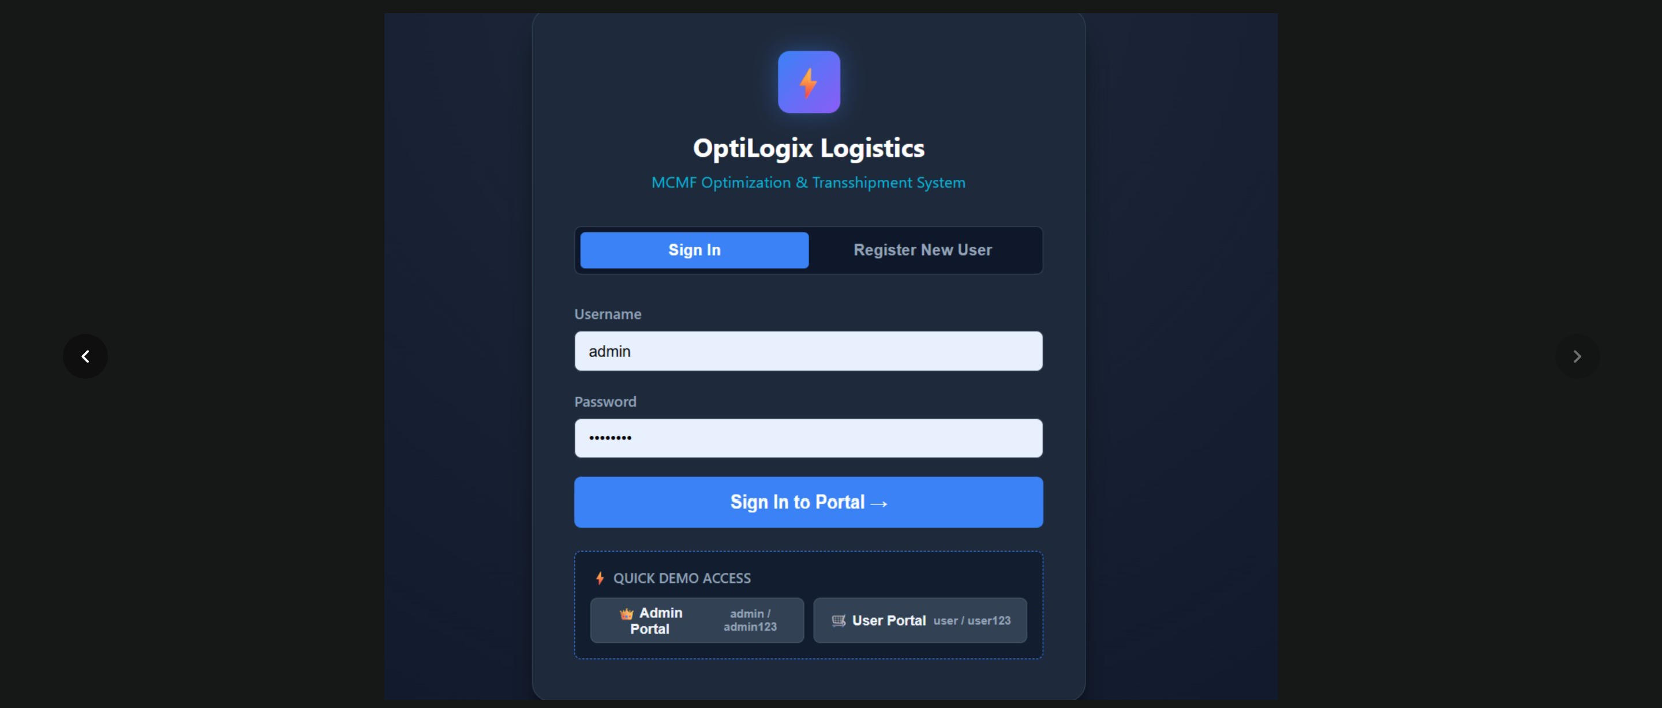

Home page:
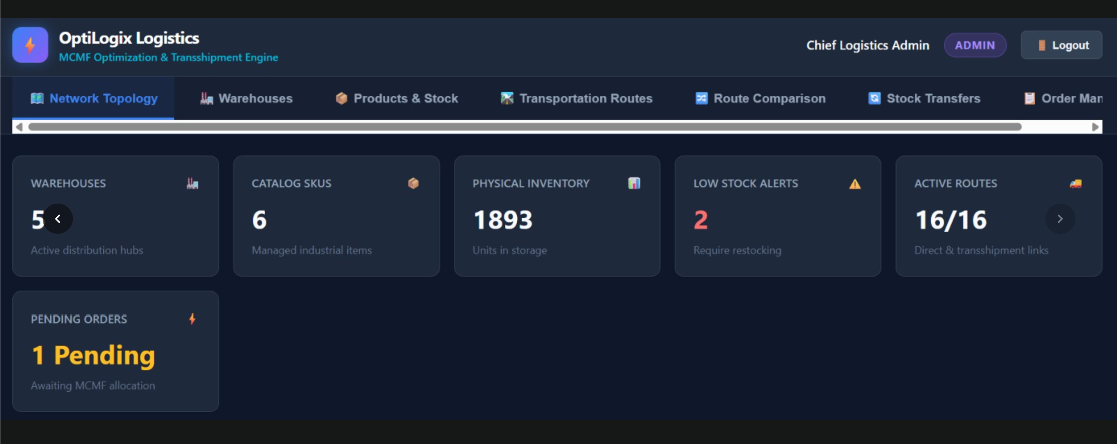

Warehouses:
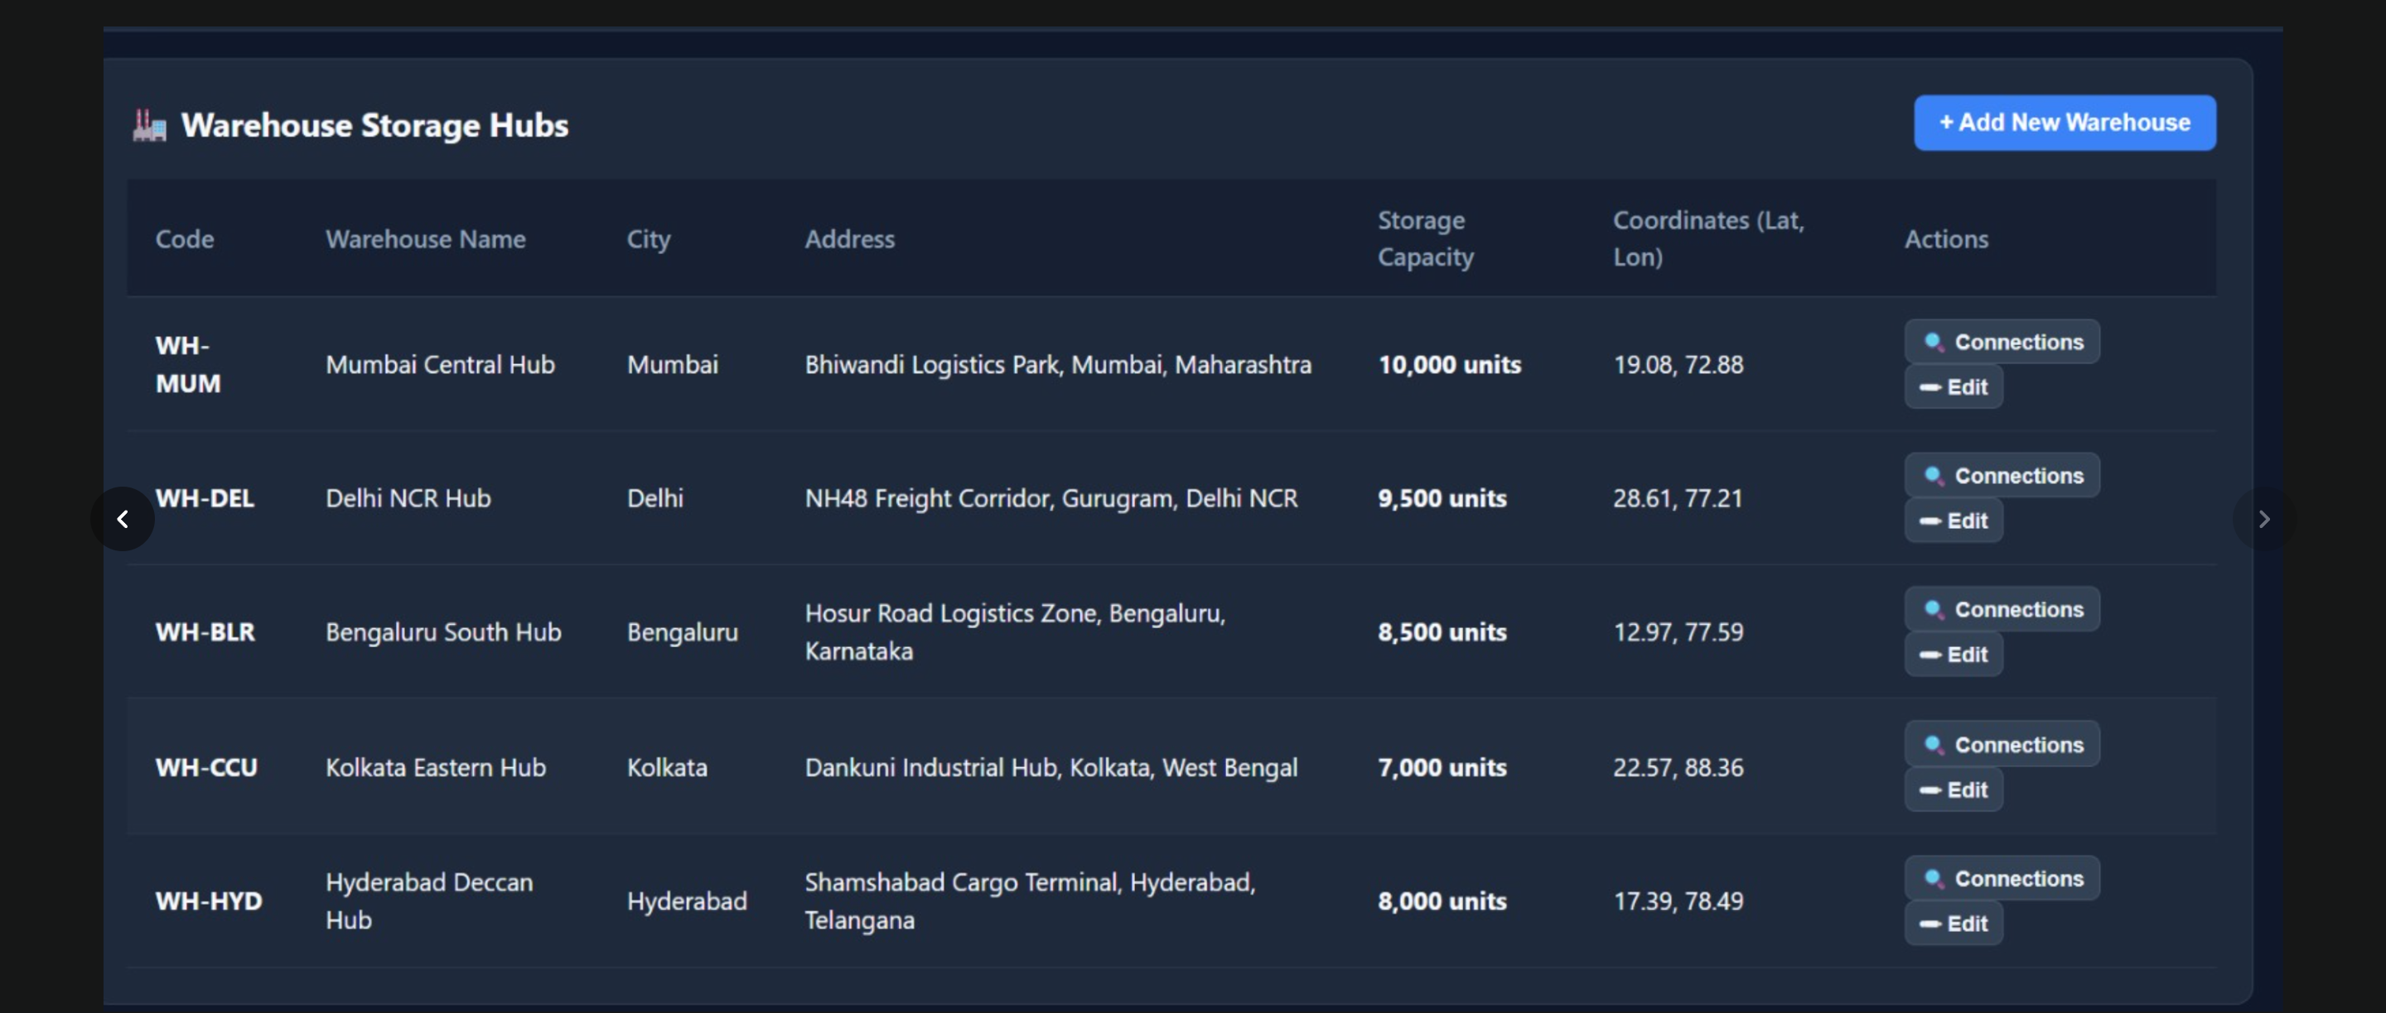

Routes:

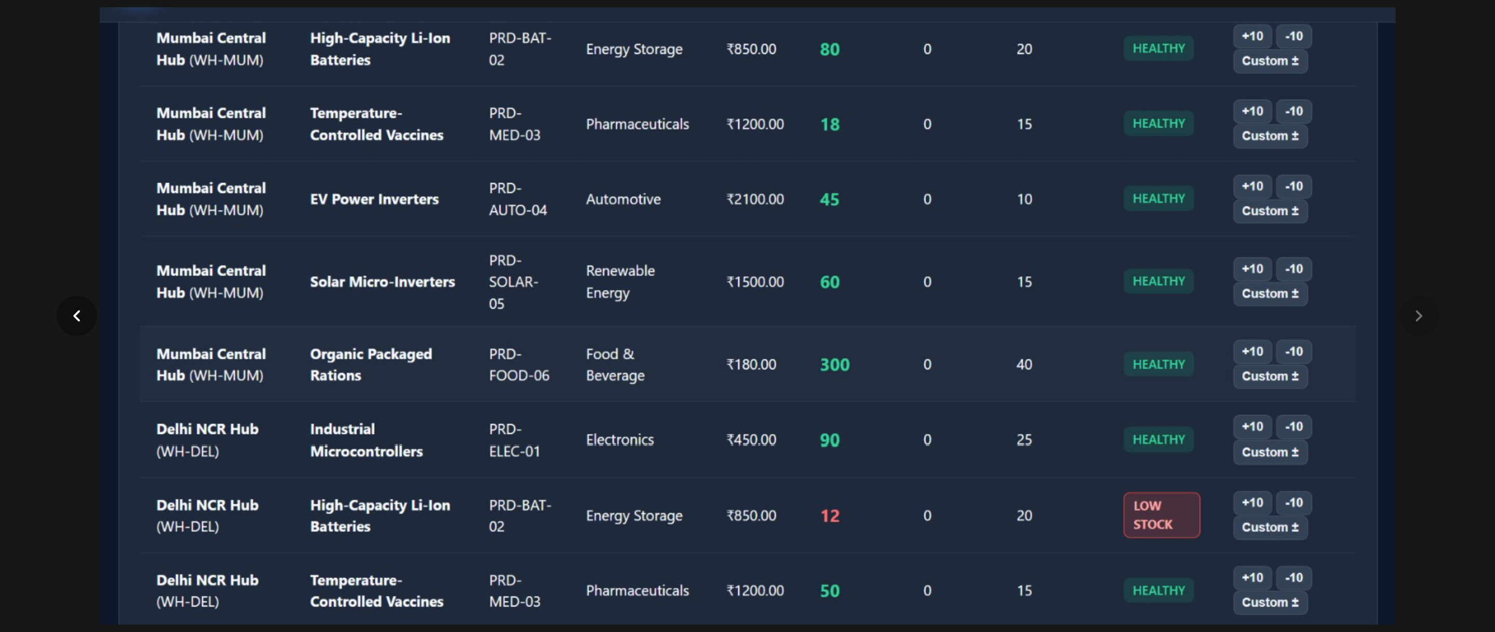

Logistic optimization result:

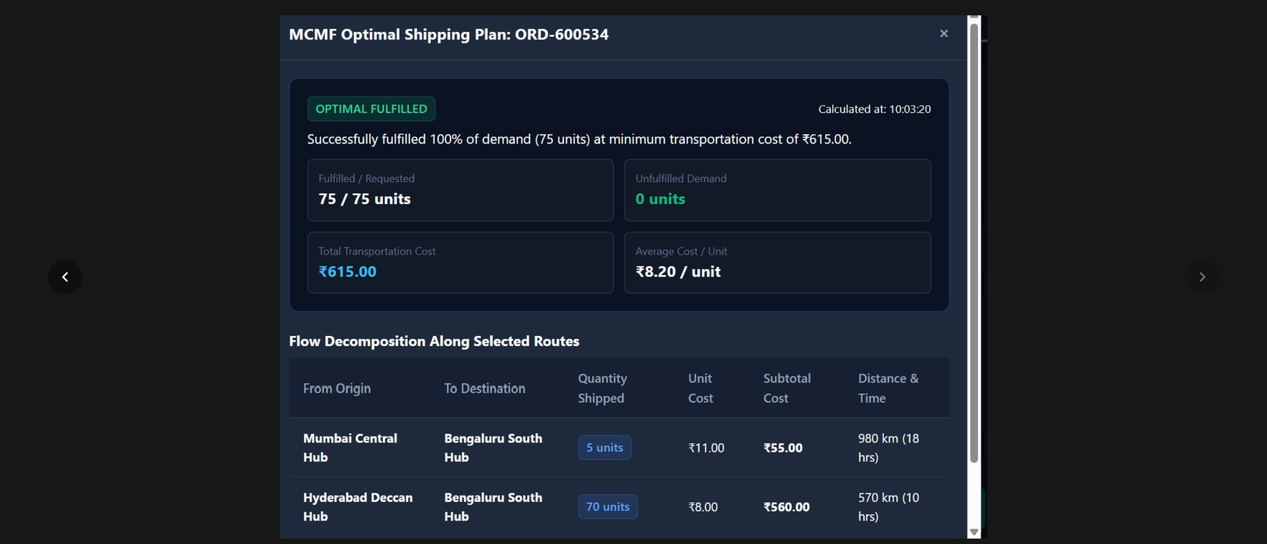

- CONCLUSION & FUTURE SCOPE
A strong conclusion should revisit your project's objectives and concisely explain whether they were met. Avoid introducing new information and focus on synthesizing your project's journey and key takeaways.

The future scope section showcases your forward-thinking approach by detailing potential enhancements and future research. This is often presented in a hierarchical fashion, outlining near, medium, and long-term possibilities.

Conclusion
The Logistics Optimization System successfully demonstrates the application of advanced Data Structures and Algorithms to a real-world transportation problem. The system models warehouses and transportation routes as a graph and uses Dijkstra's algorithm for shortest-route analysis and Minimum-Cost Maximum-Flow for optimizing the distribution of goods under capacity and demand constraints. The project demonstrates how algorithmic techniques can be used to reduce transportation cost and improve the efficiency of logistics operations.

Future Scope
The system can be further enhanced by incorporating additional real-world constraints and advanced optimization techniques.
- Real-time route optimization: Incorporate live traffic and road-condition data to dynamically update routes.
- Time-window scheduling: Add delivery deadlines and vehicle scheduling constraints.
- Advanced routing: Implement algorithms such as A*, Aho-Corasick for relevant text operations, or other optimization techniques from the DSA-3 syllabus where applicable.
- Predictive analytics: Use historical logistics data to predict demand and optimize inventory distribution.
- Large-scale optimization: Improve the algorithms to handle larger logistics networks efficiently.
- Dynamic network updates: Automatically recalculate optimal routes when a route becomes unavailable or its capacity changes.

Final Statement
Overall, the project provides a practical demonstration of how graph algorithms, shortest-path techniques, network flow, residual graphs, and optimization can be combined to solve logistics problems efficiently. It also provides a strong foundation for extending the system into a more comprehensive real-time logistics optimization platform.

- REFERENCES

• Google for Developers, “Vehicle Routing,” OR-Tools. https://developers.google.com/optimization/routing
• Google for Developers, “Minimum Cost Flows,” OR-Tools. https://developers.google.com/optimization/flow/mincostflow
• Google for Developers, “Vehicle Routing Problem,” OR-Tools. https://developers.google.com/optimization/routing/vrp
• Google for Developers, “Capacity Constraints,” OR-Tools. https://developers.google.com/optimization/routing/cvrp
• Google for Developers, “Vehicle Routing Problem with Time Windows,” OR-Tools. https://developers.google.com/optimization/routing/vrptw
• Google for Developers, “About OR-Tools”. https://developers.google.com/optimization/introduction
• IBM, “Shipment and Order Planning.” IBM Shipment and Order Planning
• Alibaba Cloud, “Logistics Transportation Network Flow Problem – Minimum-Cost Flow.” Alibaba Cloud Logistics Network Flow Optimization
• Vaidyanathan, B. and Ahuja, R. K., “Minimum Cost Flows,” Wiley Online Library. Wiley – Minimum Cost Flows
• Google for Developers, “OR-Tools Examples.” OR-Tools Examples

